OBJECT ORIENTED
PROGRAMMING
Individual Activity: E-Commerce Product Catalog Program Flow

Submitted by:
VARGAS, John Lloyd E.

Submitted to:
Sir BATOON, Jayson A.

MAIN MENU
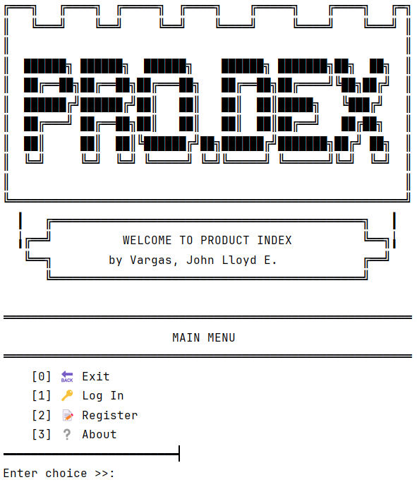

ABOUT
